Concept:

Dynamic Employee Portal with Document Centre-Downloads: A dynamic employee module to be accessed only by NA employees. Employees can login to the system and view the customized sections which include all the internal system/ application links presented in an engaging User Interface. The module should offer NA employees a one stop online portal in which once they are logged in can view and download all company documents and access through a ‘single point’ all internal systems, applications or websites (via hyperlinking and not integration).

The portal will also be used as a hub for internal news, marketplace and Department updates. The below is just a sample of a very high level look and feel.

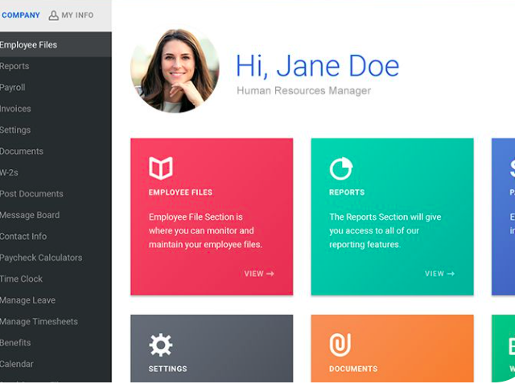

Employee can upload their photo

Welcoming Message

Hello Nour Saifi

Welcome to NA’s Employee Portal

Tabs would include

* 1) Document Library
* 2) Market Place
* 3) Team Member Salute
* 4) The Head’s Up
* 5) Stories
* 6)Internal Applications
  + Webmail
  + Kronos
  + LMS
  + OpIQ
  + ASANA
  + Oracle
  + Office365
* 7) Settings

**1) Document Library**

Attached in the email is an excel list all of all documents that need to be uploaded onto the new website as part of the Document Library. Documents will be provided at the final stage of the website to ensure we upload up to date documents. (This is a live library in which changes are made to docs very often).

Employee (Users) side

1. Search engine – where the employee search/ filter either name of the document or the controlled number (or keyword search)
2. Documents are categorized according to the department owners

Admin part – ability to update, upload, remove the document

Information needed and required when uploading or updating the documents/ or for filtration process for employees are

|  |  |  |  |  |  |  |
| --- | --- | --- | --- | --- | --- | --- |
| Controlled Number | Document Name | Version Number | Department Owner | Data Classification | Document Type | Date |

Only the admin can upload the files. The file type that could be uploaded would range from Word, PowerPoint, excel to PDF files.

Data classification drop down menu to include: Public, Restricted, Confidential

Document Type drop down menu to include: Policy, Form, Workflow, Graphics, Position Description

**2) Marketplace**- ability for users to post

What are you selling?   
Users will click on it and Username and profile photo will show while the following fields appear:

* Photos   
  Choose your listing’s main photo first.
* Category (optional)
* Title
* Price
* Location
* Description (optional)

**3) Team Member Salute**

Design: A pin board showcasing Team Member Salutes

Sample pin board photo- The board will showcase 5 values with the main message on top

When you feel a fellow staff member deserves recognition in how they live National Ambulance’s value of Respect, Excellence, Integrity, Mutual Support and Accountability, please fill out a Team Member Salute Card and post it on the E-Noticeboard.

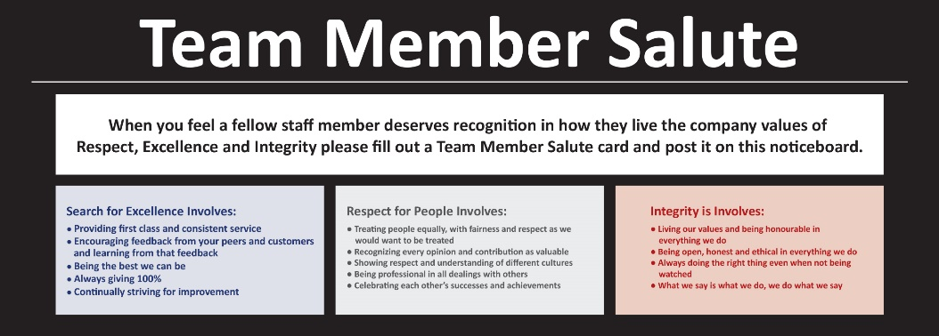

The values will be placed in blocks with different colours and a description of each.

Colours are red for integrity, navy blue for Excellence, grey for Respect, white for Mutual Support, Blue for Accountability (like the one used for the app backgrounder on the front page).

Team members can fill a form to express their appreciation/ thanks to others. In the form users should be able to choose from the following categories (Company’s values):Respect, Excellence, Integrity, Mutual Support

* Category (drop down menu)
* To:
* From:
* Date:
* For:

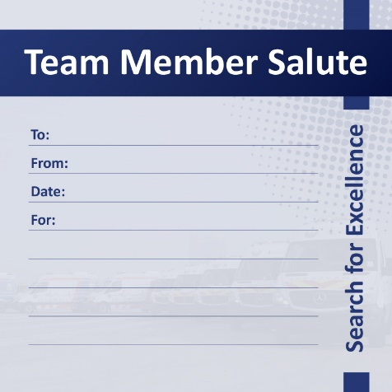

After submitting the form, the end result will look something like this if they choose excellence category. If they chose Respect for example, the same card will appear but in grey colour and the word Respect instead of Excellence.

**4) The Head’s Up**   
Ability to upload videos (not on YouTube), text and photos. It’s an update from Department Heads or C-Levels**.**

**5) Stories**

Do you have a story to tell or a photo to share? Have you witnessed or been part of a successful incident? Have you or your coworker done an extra ordinary job in saving a patient’s life? Please share with us. Your story will be reviewed before it goes live and we will get in touch if we require more details.

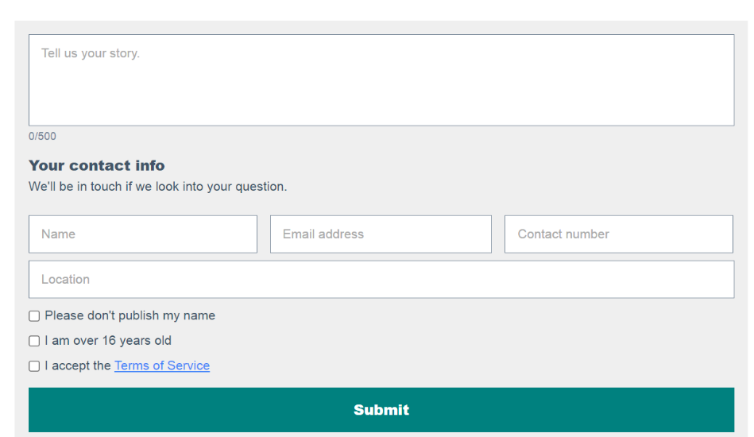

**Attach photo**

**Tick box for:**

* Please don’t publish my name
* I accept the Media Terms and Conditions

**7) Internal Applications we use:**

* WebMail                           [https://mail.nationalambulance.ae\OWA](https://mail.nationalambulance.ae/OWA)
* Kronos                              <https://workforce.nationalambulance.ae/wfc/logon>
* LMS                                    <https://training.nationalambulance.ae>
* OpIQ                                  <https://nationalambulanceuae.operativeiq.com/>
* ASANA                               <https://app.Asana.com>
* Oracle
* Office365                          <https://www.office.com/?auth=2>

**8) Settings**